Graphing Your Prediction

Using the current population of your species as the y-intercept and the mortality rate as the slope, graph your prediction of when the species would become extinct if we did nothing to preserve it?

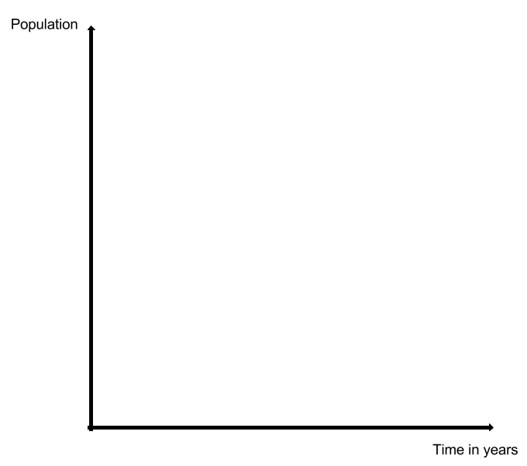

SUMMARY:
Write a paragraph that summarizes what you have learned. Be sure to include the following information: reason your species is endangered, how soon it will be extinct if we don’t take precautions, and steps toward preservation.

